Nexora examinations and results
Document 14 of the Nexora learning guides
Source snapshot 14 October 2026 at 06:41 UTC
Understand examination offerings, attendance, score publication and pass or fail outcomes.

Recognise the screen and its scope
Open /events/exams, /events/exams/[id]. CRM routes use port 3017; member routes use 3018; public website routes can use 3019. Brackets name a route parameter, not text to paste into a browser. Choose a real record or site id from the application.
This guide covers Exam offering and passing score; Candidate enrollments; Attendance prerequisite; Result score and outcome; Exam-results permission.
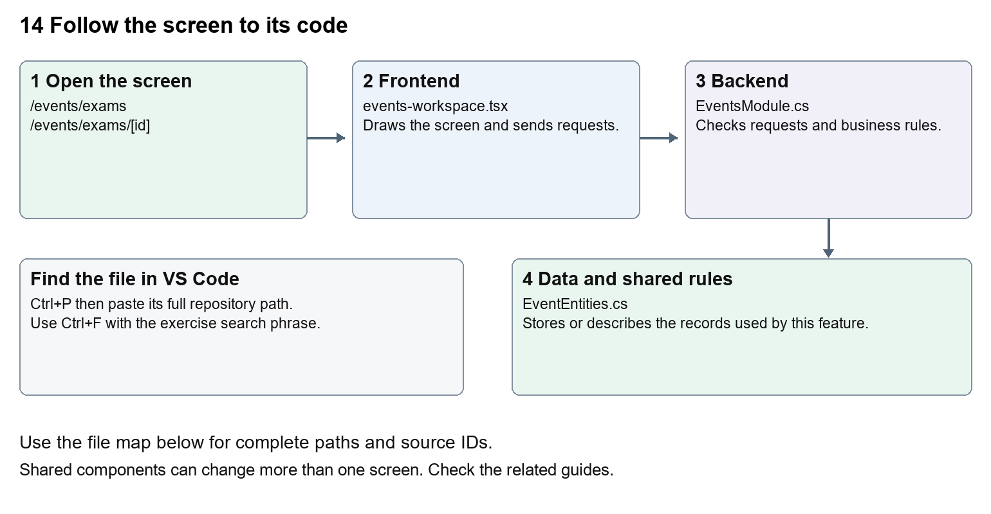
The diagram shows the file roles. The full paths below are what you paste into Ctrl+P.

Find the files in VS Code
Role | File and source ID | What it does
Screen | S0097 events-workspace.tsx | Main UI or route for this topic
Server | S0329 EventsModule.cs | Endpoints or server rules
Data | S0328 EventEntities.cs | Data shape or persistence structure

Screen S0097
apps/web/src/features/events/events-workspace.tsx
Server S0329
backend/src/Modules/Nexora.Modules.Events/EventsModule.cs
Data S0328
backend/src/Modules/Nexora.Modules.Events/Domain/EventEntities.cs
The complete HTML manual opens these source IDs inside its Source library. The Word manual shows short labelled extracts so you can learn the flow before reading large files. Each individual Markdown guide includes its complete primary files after the walkthrough.

Follow the request and the records
1. The exam route selects exam as the offering kind.
2. An enrollment links the candidate Contact to the exam.
3. Attendance is recorded before a result can be published.
4. An authorised results request sends score and expected version.
5. Server validation stores the result and calculates its outcome.

Read the code with an explanation
The results permission is separate from general event management. The screen only shows the score form for an attended exam enrollment without an existing result. Those browser conditions help usability, while the C# endpoint checks the rules again. Changing the displayed word Score does not change the passing-score calculation.
Source reference S0097 apps/web/src/features/events/events-workspace.tsx
Selected opening lines with their original numbers. The complete file is in the HTML source library.
0001 "use client";
0002 import { RecordListing } from "../shared/record-listing";
0003 import listingStyles from "../crm/record-listing.module.css";
0004 import { WorkspaceHeading } from "@/components/ui/workspace-heading";
0005 import { useRouter } from "next/navigation";
0006 import type { Route } from "next";

The import lines lead to shared components and helpers. Start at the exported component or route function; follow the request helper to the server rather than assuming the whole feature lives in this file.
Source reference S0329 backend/src/Modules/Nexora.Modules.Events/EventsModule.cs
Extract from source line 27. A fragment from a long line is shown without the rest of that line.
0027 api.MapGet("/contacts",(string? search,ICrmDirectory crm,CancellationToken ct)=>crm.SearchContactsAsync(search,ct));

On the server, look for MapGet to load records, MapPost to create or perform an action, MapPut or MapPatch to change data, and RequireAuthorization for permissions. Some shared methods register endpoints indirectly. Find SaveChangesAsync to see the database write. A request method alone does not tell you every side effect.
Source reference S0328 backend/src/Modules/Nexora.Modules.Events/Domain/EventEntities.cs
Selected opening lines with their original numbers. The complete file is in the HTML source library.
0001 using Nexora.BuildingBlocks.Domain;
0002 namespace Nexora.Modules.Events.Domain;
0003 public sealed class Offering : TenantEntity
0004 {
0005 public string Kind { get; set; } = "event";
0006 public string Name { get; set; } = "";

Follow model fields to their request names and database mapping. An id points to a particular record. A tenant id limits the organisation. A version or concurrency stamp protects newer edits. Some model files describe contracts rather than tables; check the owning DbContext before assuming storage.

Make or trace your first change
1. Press Ctrl+P and open apps/web/src/features/events/events-workspace.tsx.
2. Press Ctrl+F and search for Exam score. In this snapshot it appears at line 31.
3. Replace only the result field label. Inspect the exam result form using an authorised test enrollment. Do not publish or alter a real result while practising.
4. Replace only Exam score with Candidate score in that intended location. Keep quotes, tags, JSON keys and routes intact.
5. Save with Ctrl+S. Inspect Problems and the local screen. Review the diff and restore the original text when you finish practising.
Extract from source line 31. A fragment from a long line is shown without the rest of that line.
0031 l.offering.id);});}}><Field label="Exam score"><input className={input} name="score" type=

These exercises have not been applied to the application. Their search phrases are verified against the captured source. Line numbers can move; the phrase and file path are your main navigation aids.

Check a change and diagnose problems
Confirm the original screen still loads, the changed words appear in the intended place, and another screen using the same component still behaves correctly. If an action fails, inspect the browser Network response, the relevant helper and server validation message. Use the common error table at the beginning of the manual. Reload on a version conflict instead of removing the version check.
A syntax error after a text edit usually means a quote, brace or closing tag changed. Compare your diff with the original. An unchanged browser result can mean the wrong port, a saved published configuration overriding a default, or a running API that has not reloaded.

Understand the current limits
The current module stores exam outcomes; it does not establish a live proctoring service, external examination-board integration or automatic certificate distribution.

Continue learning
Related guides 12 Nexora events and bookings, 13 Nexora courses and training, 20 Nexora administration and access.

